Digital Suggestion Box for Smart Local Park
PBL-ICT Reference:
For card (hover text appears from bottom to top):
https://www.youtube.com/watch?v=o4rYSjRWG0o
For form design (From Pinterest):
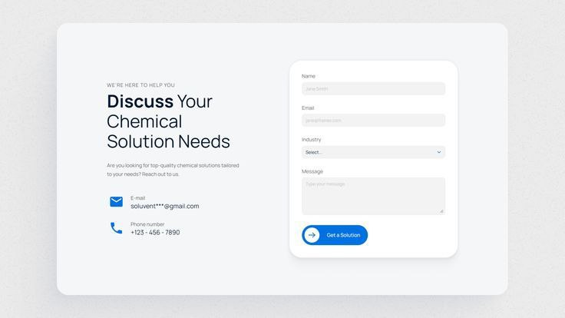
For emoji star (List style):
https://emojipedia.org/star
For background image opacity:
https://www.youtube.com/watch?v=pyPfpXaH2kY
For image and icon:
https://www.flaticon.com/
https://unsplash.com/
https://www.pinterest.com/

